AP Chemistry Unit 9 Thermodynamics & Electrochemistry Problem Sets
Problem Set 1
1 | 2
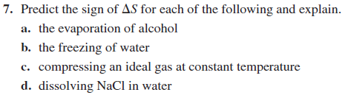 | 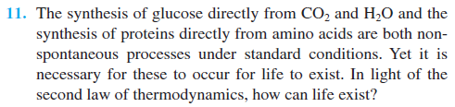
3 | 4
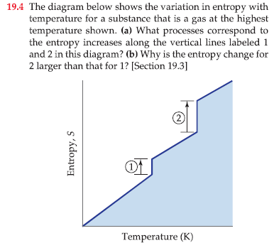 | 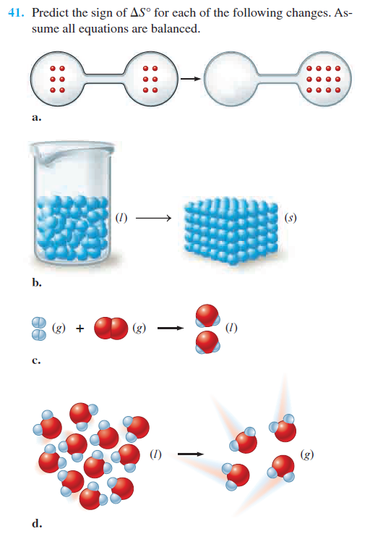
5 | 6
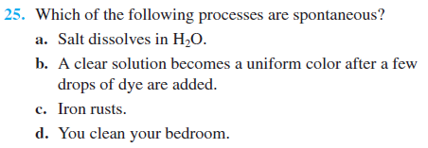 | 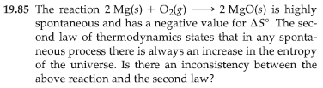
7 | 8
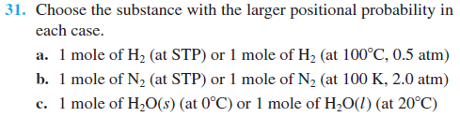 | 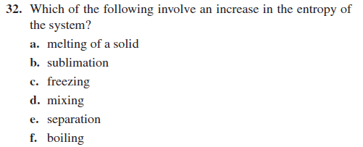
9 | 10
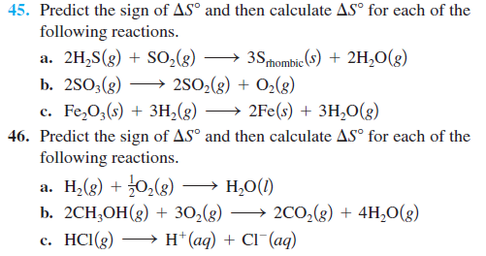 | 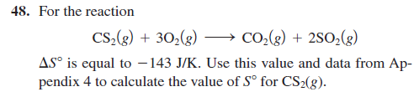
11
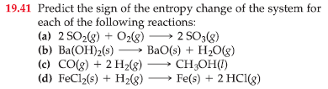

Problem Set 2

1 | 2
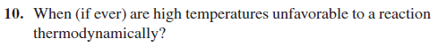 | 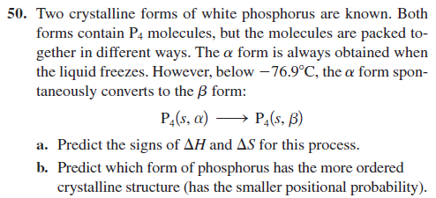
3 | 4
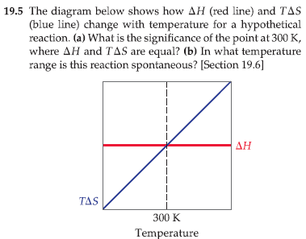 | 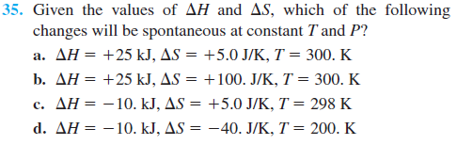
5 | 6
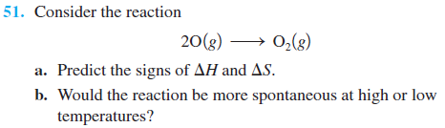 | 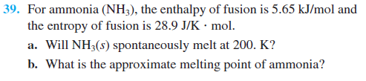
7 | 8
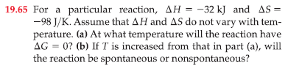 | 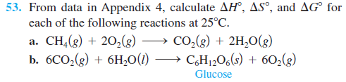  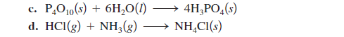
9 | 10
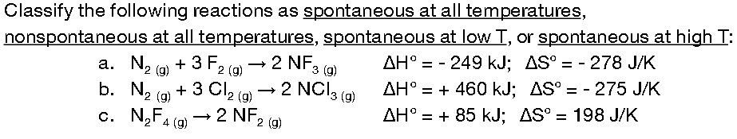 | 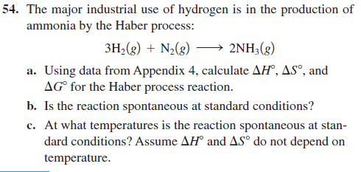
11 | 12
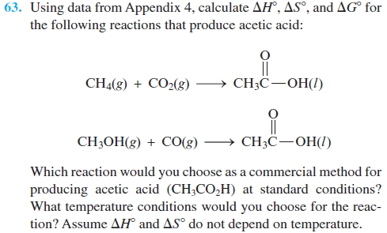 | 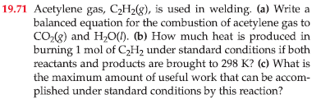
13 | 14
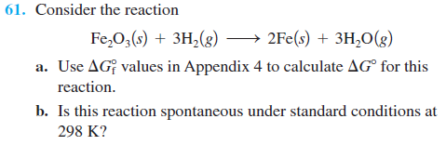 | 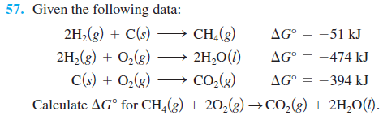
15 | 16
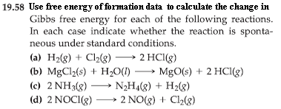 | 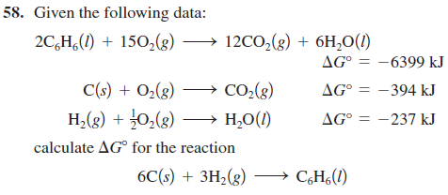

Problem Set 3

1 | 2
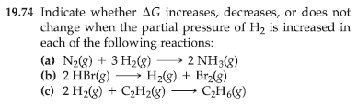 | 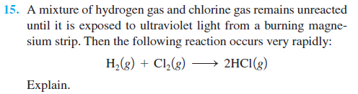
3 | 4
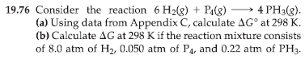 | 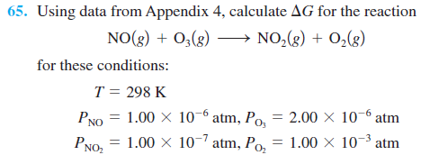
5 | 6
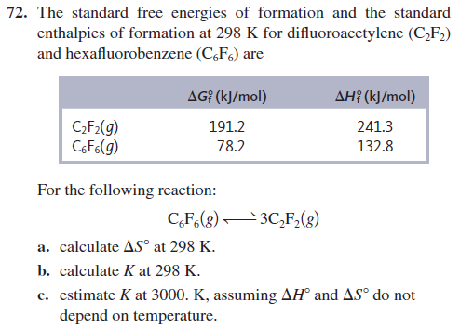 | 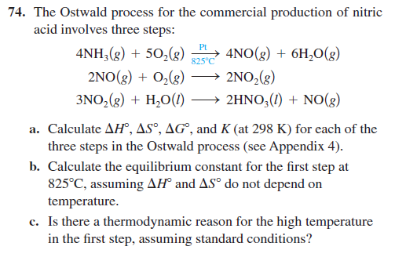
7 | 8
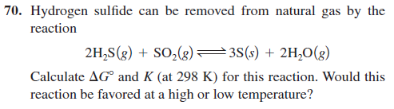 | 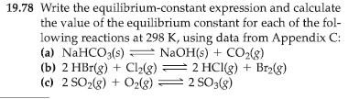
9 | 10
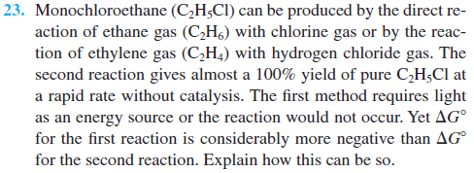 | 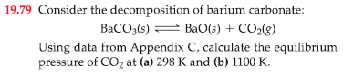
11 | 12
Answer the following questions of biological energy production in cells:  (a) Cells use the hydrolysis of adenosine triphosphate, abbreviated as ATP, as a source of energy. The reaction can be written:  ATP_{(aq)} + H₂O _{(l)} → ADP_{(aq)} + H₂PO₄⁻_{(aq)}.  Calculate K at 25°C for this reaction that has ∆G° = - 30.5 kJ/mol.  (b) One reaction that occurs in human metabolism is:  glutamic acid_{(aq)} + NH_{3(aq)} ←→ glutamine_{(aq)}.  For this reaction, ∆G° = 14 kJ at 25°C. Calculate K.  (c) In a living cell, these reactions are coupled. Calculate ∆G° and K at 25°C for the following reaction:  glutamic acid_{(aq)} + ATP_{(aq)} + NH_{3 (aq)} ←→ glutamine_{(aq)} + ADP_{(aq)} + H₂PO₄⁻_{(aq)} | 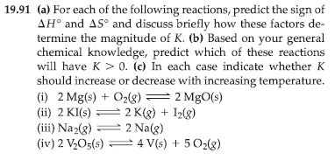

Electrochemistry

I. Oxidation and Reduction PROBLEM SET

A) I can differentiate between oxidation and reduction.

1) oxidation = ___________________________________________________________

2) reduction = ___________________________________________________________

B) I can assign oxidation numbers to each element in a compound or ion.

1) Assign oxidation numbers for each element in the following:

Na₂SO₄ Na _____ S _____ O _____

N₂ N _____

NO₂ N _____ O _____

Cr₂O₇²⁻ Cr _____ O _____

I₃⁻¹ I _____

C) I can predict the products of a single replacement redox reaction using a table of reduction
potentials or activitiy series.

1) Cu(s) + AgNO₃(aq) ⇒ __________________________________________

2) Zn(s) + CuCl₂(aq) ⇒ __________________________________________

3) NaI + Cl₂(g) ⇒ __________________________________________

D) I can identify the element being oxidized and the element being reduced in a reaction.

Identify the element being oxidized and the element being reduced:

1) MnO₄⁻ + Fe²⁺ → Mn²⁺ + Fe³⁺

oxidixed ______________ reduced _______________

2) Cd + NiO₂ + 2 H₂O → Cd(OH)₂ + Ni(OH)₂

oxidixed ______________ reduced _______________

E) I can identify the oxidizing agent and the reducing agent in a reaction.

Specify which of the following equations represent oxidation-reduction reaction, and indicate the
oxidizing agent, the reducing agent, the species being oxidized, and the
species being reduced.

1) CH₄(g) + H₂O(g) → CO(g) + 3H₂(g)

2) 2AgNO₃(aq) + Cu(s) → Cu(NO₃)₂(aq) +2Ag(s)

F) I can write a balanced equation for a redox reaction that occurs in acidic or basic solution.

Balance each of the following equations by the half-reaction method for the pH conditions
specified (without predictions)

1) Cr(s) + NO₃⁻(aq) → Cr³⁺(aq) + NO(g) (acidic)

2) Al(s) + MnO₄⁻(aq) → Al³⁺(aq) + Mn²⁺(aq) (acidic)

3) PO₃³⁻(aq) + MnO₄⁻(aq) → PO₄³⁻(aq) + MnO₂(s) (basic)

II. Electrochemical Cells

A) I can use a reduction table to predict what element is being oxidized and what element is being reduced in an electrochemical cell.

1) Answer the following questions using data from Table 17.2 (all under standard conditions)
and explain briefly in each case.

a) Is H⁺(aq) capable of oxidizing Cu(s) to Cu²⁺(aq)?

b) Is Fe³⁺(aq) capable of oxidizing I⁻(aq)?

c) Is H₂ (g) capable of reducing Ag⁺(aq)?

d) Is Fe²⁺(aq) capable of reducing Cr³⁺(aq) to Cr²⁺(aq)?

B) I can predict and describe the construction and properties of voltaic/galvanic cells
- I can use half-reactions to write the net redox reaction.
- I can identify the cathode and the anode in a redox reaction.
- I can determine the theoretical voltage produced in an electrochemical cell.
- I can explain the flow of electrons in the cell and the flow of ions in the salt bridge.
- I can identify the relationship between voltage and spontaneity.

- Given each of the following materials, (1) draw the electrochemical cell, (2) draw the direction of electron flow, (3) identify the anode and the cathode, (4) write the line notation for the cell, and (5) calculate the E°_{cell}

a) Ag (s) and 1.0 M Ag⁺ (aq) with Cu (s) and 1.0 M Cu²⁺ (aq)

b) Fe²⁺ (aq) and Fe³⁺ (aq) with MnO₄⁻ (aq) and Mn²⁺ (aq)

- Sketch the galvanic cells based on the following overall reactions. Show the direction of
electron flow and identify the cathode and anode. Give the overall balanced reaction.
Assume that all concentrations are 1.0 M and that all partial pressures are 1.0 atm.

a) Cr³⁺ (aq) + Cl₂ (g) ←→ Cr₂O₇²⁻ (aq) + Cl⁻ (aq)

b) Cu²⁺ (aq) + Mg (s) ←→ Mg²⁺ (aq) + Cu (s)

c) Calculate E° values for the galvanic cells sketched above.

- Sketch the galvanic cells based on the following half-reactions. Show the direction of
electron flow, show the direction of ion migration through the salt bridge, and identify the
cathode and anode. Give the overall balanced reaction, and determine E° for the galvanic
cells. Assume that all concentrations are 1.0 M and that all partial pressures are 1.0 atm.

a) H₂O₂ + 2 H⁺ + 2 e⁻ → 2 H₂O E° = 1.78 V
O₂ + 2 H⁺ + 2 e⁻ → H₂O₂ E° = 0.68 V

b) Mn²⁺ + 2 e⁻ → Mn E° = -1.18 V
Fe³⁺ + 3 e⁻ → Fe E° = - 0.036 V

c) For each of the following galvanic cells, give the balanced cell reaction and determine E°.

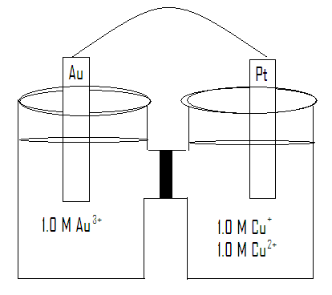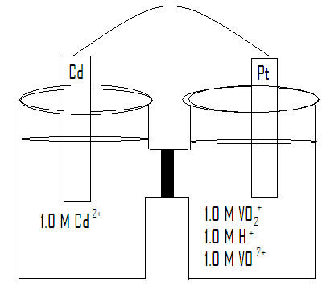

reaction ____________________________ reaction ___________________________

Eº _______________ Eº _______________

III.Gibbs, Galvanic Cells with Different Concentrations PROBLEM SET

A) I can calculate the Gibbs free energy for the net redox reaction in a cell.

1) Chlorine dioxide (ClO₂), which is produced by the reaction,

2 NaClO₂ (aq) + Cl₂ (g) → 2 ClO₂ (g) + 2 NaCl (aq)

has been tested as a disinfectant for municipal water treatment. Using data from the
table below, calculate E° and ΔG° at 25°C for the production of ClO₂.

B) I can calculate the equilibrium constant for a reaction given its Gibbs free energy and its cell
potential.

Under standard conditions, what reaction occurs, if any, when each of the following
operations are performed? For the reactions that occur, write a balanced equation and
calculate E°, ΔG°, and K at 25°C.

1) Crystals of I₂ are added to a solution of NaCl.

2) Cl₂ gas is bubbled into a solution of NaI.

3) A silver wire is placed in a solution of CuCl₂.

4) At 25°C, H₂O₂ decomposes according to the following equation:

2 H₂O₂ (aq) → 2 H₂O (l) + O₂ (g)

Reduction ½ Rxn | Eº
H₂O₂ + 2 H⁻ + 2e⁻ → 2 H₂O | 1.78
O₂ + 2 H⁺ + 2e⁻ → H₂O₂ | 0.68

- Determine the value of the standard free energy, ΔG°, for this reaction.

- Determine the equilibrium constant, K, for this reaction.

C) I can explain the effect of changing the concentration of a solution in an electrochemical cell.

D) I can use the Nernst equation to calculate the voltage of an electrochemical cell where the two
solutions have different concentrations.

1) A galvanic cell is based on the following half-reactions at 25°C:

Ag⁺ + e⁻ → Ag
H₂O₂ + 2 H⁺ + 2 e⁻ → 2 H₂O

Predict whether E_{cell} is larger or smaller than E°_{cell} for the following cases:

    - [Ag⁺] = 1.0 M, [H₂O₂] = 2.0 M, [H⁺] = 2.0 M

    - [Ag⁺] = 2.0 M, [H₂O₂] = 2.0 M, [H⁺] = 1.0 x 10⁻⁷ M

E) I can predict which way electrons will flow in an electrochemical cell where the same metal is the
electrode on both sides of the cell and calculate its voltage.

Consider the concentration cell shown below. Calculate the cell potential at 25°C when the
concentration of Ag⁺ in the compartment on the right is the following. Also, for each case,
identify the cathode, the anode, and the direction in which electrons will flow.

1) 1.0 M | 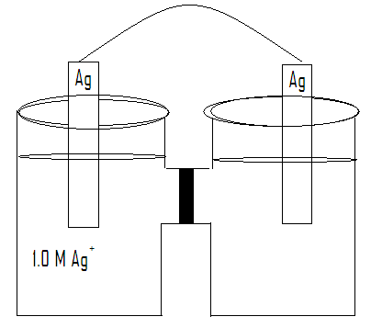
2) 2.0 M

3) 0.10 M

4) 4.0 x 10⁻⁵ M

IV. Electrolysis PROBLEM SET

A) I can explain the difference between a galvanic cell reaction and an electrolysis reaction.

B) I can identify the processes for which electrolysis reactions are used.

C) I can calculate the mass of plated material produced given the current, the time, and the
substance used, or vice versa.

1) In an electrolytic cell, Cu is produced by the electrolysis of CuSO₄ (aq). Calculate the
maximum mass of Cu (s) that can be deposited by a direct current of 100 amps passed
through 5.00 L of 2.00 M CuSO₄ (aq) for a period of 1.00 hr.

2) How long will it take to plate out each of the following with a current of 100.0 A?

a) 5.0 mol Ag from aqueous Ag⁺

b) 1.0 kg Al from aqueous Al³⁺

D) I can calculate the mass of metal produced given the amount of another metal and the time of the
process.

1) A steady electric current is passed through molten MgCl₂ for exactly 1.00 hour, producing
243 grams of Mg metal. If the same current is passed through molten AlCl₃ for 1.00 hour,
what is the mass of Al metal produced?

E) I can predict the order that different metals will be plated using their reduction potentials.

1) A solution at 25°C contains 1.0 M Cd²⁺, 1.0 M Ag⁺, 1.0 M Au³⁺, and 1.0 M Ni²⁺ in the
cathode compartment of an electrolytic cell. Predict the order in which the metals will plate
out as the voltage is gradually increased.

F) I can write electrolysis equations.
- I can identify whether the cation will undergo electrolysis or water will be better.
- I can identify whether the anion will undergo electrolysis or water will be better.

Write a net ionic equation for the following electrolysis reactions:

1) A solution of copper(II) sulfate is electrolyzed in water.

2) A solution of potassium iodide is electrolyzed in water.

3) Aqueous cobalt(II) bromide is electrolyzed in water.

4) A solution of nickel(II) nitrate is electrolyzed in water.

5) The compound NaI dissolves in pure water. Some of the information in the table of
standard reduction potentials given below may be useful in answering the questions that
follow.

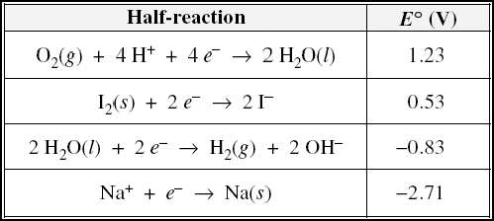

An electric current is applied to a 1.0 M NaI solution.

a) Write the balanced oxidation half-reaction for the reaction that takes place.

b) Write the balanced reduction half-reaction for the reaction that takes place.

c) Which reaction takes place at the anode, the oxidation reaction or the reduction reaction?

d) All electrolysis reactions have the same sign for ΔG°. Is the sign positive or negative? Justify your answer.

