Soil Labs
Soil has many different characteristics – this tab will introduce you to several of the
characteristics.
Materials:
1 cup of each: Sand, Clay, Silt, your sample
(2)100mL graduated cylinder
Balance Funnel
6-8 pieces of filter paper Water Bottle
2 large test tubes Test tube rack

1. Soil Texture – refers to proportions of sand, silt, and clay sized particles. This
Proportions determine, water infiltration rates, permeability rates and water holding rates.
There are 2 ways to determine type of soil texture. We will experiment with both of
these techniques.

We can use a soil texture triangle to identify types of soil. Practice by using the
triangle below and identify the different types of soil:

Example: Sandy Loam
65% Sand, 20% Silt and 15% clay
Practice:
__37% Sand, __42% Silt and __21% clay
Soil type: _________________
__5% Sand, __70% Silt and __25% clay
Soil Type: ________________
__55% Sand, __5% Silt and __40% clay=
Soil Type: ________________

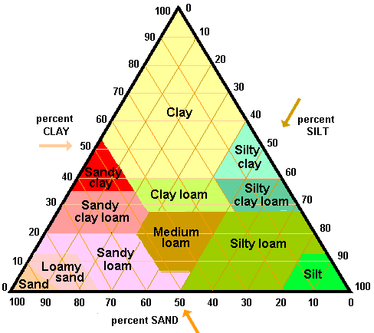

2. Soil Texture determination by fractionation

Sand is larger and so will settle out faster in a suspension, silt is the next in size so it
then settles out next. Clay is the smallest size particle so they will settle on top.

- Fill a 100mL graduated cylinder with 25mL of your soil sample.
- Add water until there is about 75mL in the cylinder.
- Cover the cylinder with film and invert several times until the soil was thoroughly suspended in the water. Place the cylinder on the lab station and leave it to settle for at least 30 minutes.
- When the soil has settled out, there should be 3 distinct layers. Measure the volume of each layer and the total volume of the sample.
- Calculate the percentage of each component.
Amount of each component x 100= % component
Total volume of soil

3. Density- dense soils have high strength, low porosity and poor plant growth. Soils can become more dense due to compaction of heavy equipment or traffic.
1. Weigh out 15 grams of sand.
2. Pour into the dry 100 ml graduated cylinder Tap gently on the table to settle the particles
3. Determine the volume in the cylinder Pour out the sample into the filter paper.
4. Calculate the bulk density and put in the chart below
5. Repeat steps 1 - 4 for Clay, Silt and your sample. Use gravel in place of silt is silt is not available.
Sample | Weight | Volume | Density (g/ml)
Sand

Clay

Silt

Your sample

Which has the greatest density?
Which has the least density?
Which has the greatest total porosity?
Which has the least total porosity?
Which can hold more water?
What is the relationship between texture and porosity?
4. Water Holding Capacity of soil- Permeability
1. Fold a piece of filter paper and place it in the funnel Put 20 ml of the sand into the
funnel.
2. Hold funnel of soil over the beaker and pour 10 ml of water into the funnel. Time
how long it takes for the water to begin coming out of the bottom and the time it takes
water to stop coming out of the bottom. The time interval indicates the permeability
or hydraulic conductivity of the soil.

3. Fill out the chart below and repeat for each of the other samples
Sample | Rate for water to move through sample
Sand

Clay

Silt

Your sample

5. Porosity of Various Soils
Background: The groundwater that we use is found in Aquifers. Aquifers are made up of rock or loose soils that can hold and easily release their waters. To do this, these units must be composed of porous and permeable materials.
Porous: refers to the amount and size of the spaces between soil or rock particles. The porosity of the rock is determined by the amount of water it is able to hold. Materials like sands and gravels have a lot of spaces between particles in which they can hold watwer. Because of this, sands and gravels have a high porosity. Clays are also very porous---- some can hold up to 60 percent of their total volume.

Permeable: refers to the rate at which water moves through the rocks or soil. Materials like sand, gravels and some limestones are both porous and permeable. The spaces are connected, allowing water to move easily through them. While clay is very porous, it is not very permeable. Its fine particles fit together and do not allow water to move easily through it. Because of this, clays are said to be Impermeable.

Objective: To determine the water holding capability, or porosity of various soil samples

Materials:
Dry clay 4 small paper cups
Dry gravel graduated cylinder
Dry sand water
Procedure:
- Fill three of the paper cups about ¾’s full each of sand, silt and clay.
- Fill the graduated cylinder with water. Slowly pour water into the first cup. Let the water seep through the sand. Slowly add more water and until a small pool of water is visible at the surface. At this point, the soil can hold no more water.
- Record the amount of water you added to the sand
- Repeat steps 2 & 3 for the clay, gravel, and mixture.
- Graph results of the amount of water used for the four types of soil.

Questions:
- Which soil sample was able to hold the most water?
- Which soil sample was able to hold the least water?
- Why can some soil hold more water than other?
- What do the results of this experiment tell us about the porosity of the soils tested?

Amount of
Water Added SAND CLAY GRAVEL MIXTURE
200ml

150ml

100ml

50ml

0ml

6. Ion Exchange Capacity
Soil can adsorb and release cations for plant nutrients. This property of cation exchange is due to the electronegativity found on clay and humus particles. Certain chemical dyes posses a negative or positive charge and can simultate the behavior of the typical anions (NO-3, C1-) and Cations (K+, H+, Ca++, Mg++, A1+++) found in soil. Methyl Red has a positive charge and Crystal Violet has a negative charge.
- Put filter paper in 2 funnels and add 20mL of you soil sample.
- Place the funnels in the large Put test tubes.
- Pour 20mL of Methyl Red dye into one of the funnels.
- Pour 20mL of Crystal Violet into the other funnel.

- What was the color of the filtrate of each sample?

2. Which dye was absorbed?
3. What is the net charge on the soil?
4. What type of soil would be best for cation absorbtion?

If time allows you, you may want to do step 3 with samples of sand, clay, and humus to check your prediction.

- How does this soil property influence the use of soil for waste treatment disposal?
- What type of soil would not be good for a water treatment plant?

Wash up all equipment and return to teacher. Make sure that you do not pour any soil samples down the drain.

Hint: If soil isn’t limed the soil is too negative and it doesn’t absorb nitrates. The result is pollution of groundwater and runoff. Clay and Humus have negative charges and can attract positively charged particles
Cations- K+,Ca+,Mg+,H+,Al+,Zn+,Pb+,Ni+,Cd+
Anions – Cl -, NO3-

7. Demonstration of Particle Size Fractionation
A simple demonstration of the fractionation of a soil sample into its components can be provided with the following activity. This activity is most effective if a surface soil and subsoil sample of different texture can be compared. Several soils of different textures would offer the best demonstration.
1. Prepare a soil sample by crushing by hand to breakdown aggregates as fine as possible.
2. Place 1 cup of soil in a quart jar.
3. Add 3 tablespoons of non-sudsing detergent (dish washer detergent) or Calgon to jar. This sodium-containing chemical acts as a dispersing agent to break down the soil aggregates into separate sand, silt and clay particles.
4. Add 3 cups of water, cover jar and shake vigorously, at intervals for 5-10 minutes.
5. Let stand for 24 hours
6. Measure the height of the sediment
7. The total depth from the 24-hour measurement gives sand, silt and clay. Subtracting the depth found in step 8 from the 24-hour measurement gives the proportion of clay.
11. Dividing the depth of each size-fraction by the total 24-hour depth and multiplying by 100 will give the percentage of sand, silt and clay.
The above procedure demonstrates the sedimentation procedure for particle-size analysis. The actual analytical method placing the well dispersed sample in a liter cylinder, stirring and measuring the quantity of material near the surface after the appropriate settling times as defined by Stoke’s Law. A sample can be taken at 10 centimeters with a pipette or a hydrometer can be used to measure the concentration of material remaining in suspension. A few simple mathematical calculations complete the determination of the particle-size analysis.

Height of sand/height of total sediment x100 = %
Height of silt/height of total sediment x100 = %
Height of clay/ height of total sediment x 100 = %

Then use the soil triangle to determine what type of soil you had

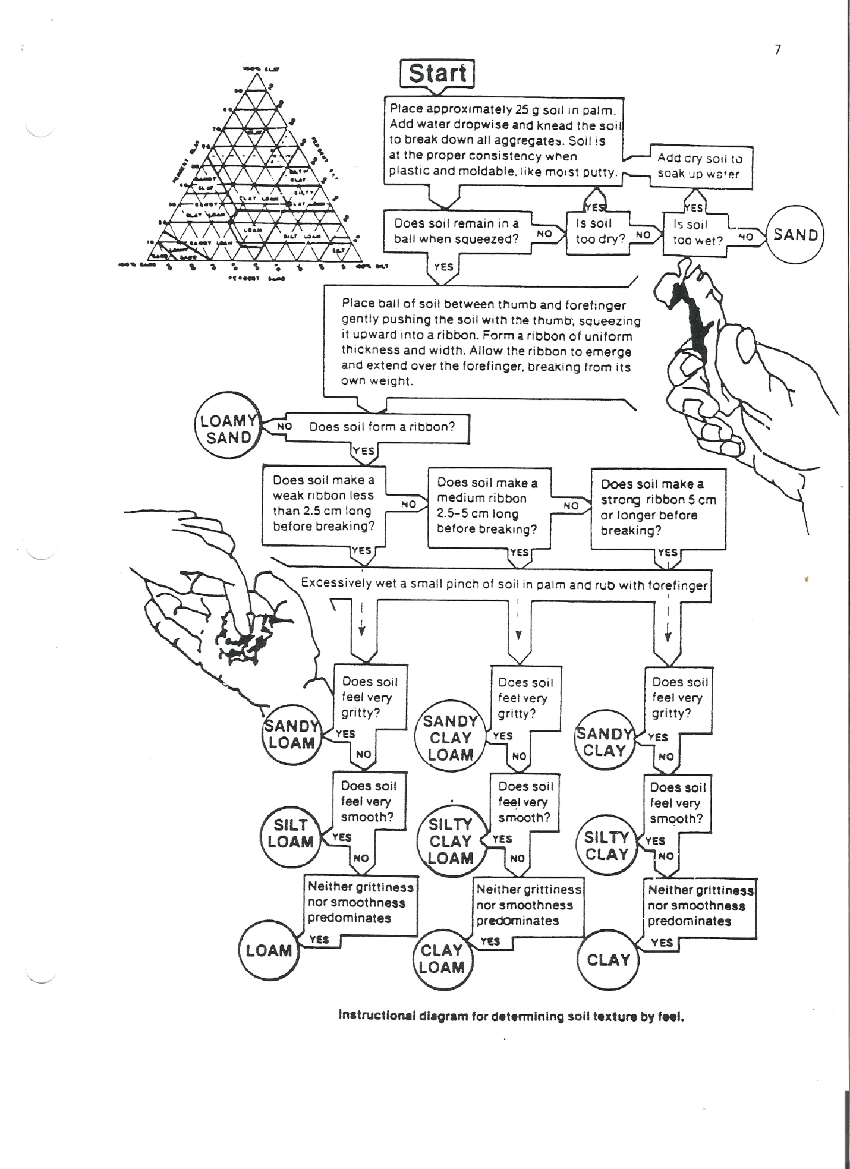
9. Expressing Water Content
A simple example of the use of math and physics is in the expression of soil water content. A gravimetric moisture determination involves weighing a moist sample, oven-drying it overnight at 105°C and reweighing. The moisture content is always expressed in relation to the oven-dry weight in the following formula:

wet weight minus dry weight X100 = % moisture by weight
Oven-dry weight
Water Holding Characteristics
A very practical application of soil-water relations is the ability of soils to retain water for plant growth. We are generally aware that sandy soils tend to be drouthy, that is, plants begin to wilt due to moisture deficit in a relative short period of time. Finer texture soils can hold more water because they have more small pores (micropores) that retain water against the force of gravity drainage.
To demonstrate the differential water holding characteristics of soils of contrasting texture collect a sandy, a loamy and a clayey soil. Crumble soils by hand while moist and let air-dry. Crush the soils with a mortar and pestle or use a rolling pin to finely grind the samples.
1. Fill a styro-foam or plastic cup with each soil and weigh.
2. Punch several holes in the bottom of each cup and place in a pan of water so the soils become fully saturated.
3. Remove from the pan of water and weigh the samples. Record this as the saturated weight.
4. Set the cups on paper towels and let drain for 24 hours. In this period of time the large pores (macropores) will drain and the soil will be at near full capacity of plant available water. Weigh and record weight as field capacity.
5. Oven dry samples at about 175°F (80°C) for 24 hours. Don't melt
plastic cup. You may wish to transfer samples to a glass or metal container and dry at 220°F (105°C).
6. Weigh sample after oven-drying and record results as oven-dry weight.
7. Calculate the moisture content percentages using the relationship:
wet weight minus oven-dry weight X 100 = % water oven—dry weight
8. Compare the results for soils of different texture. Compare the total water holding percentages using the saturated weights and compare the plant available water holding capacities using the moisture percentages calculated from the field capacity weights.

- SOIL NUTRIENTS AND PH
pH is a measure of the concentration of hydrogen ions in a solution. It is the most common method of expressing acidity. pH is measured on a scale that runs from0 to 14. 7 represents a neutral solution. A solution with a pH below 7 is acidic. A solution with a pH above 7 is basic. Many minerals are more soluble in an acidic medium than an alkaline one. pH of the soil determines which minerals will remain in the upper soil layers and which will be leached through to the lower layers. This will determine the organisms present in the soil.
The elements, nitrogen, phosphorus, potassium and calcium are essential to the growth and development of plants and animals. All of these with the exception of nitrogen are released from the soil by weathering.
MATERIALS
LaMotte Soil test Kit and Soil sample
PROCEDURE: Follow the instructions contained in the kit and test the soil for pH, nitrogen, phosphorus, and potassium
Test | Results
Nitrogen
Phosphorus
Potassium
pH
Discussion:
1. Do you think the plants in this soil sample are getting the essential nutrients that they need? Be specific.

2. Does a relationship seem to exist between the minerals found in your soil
sample and the pH?

3. Do you think precipitation would affect the minerals in the soil?

