SOIL LAB: NAMES:___________________ PERIOD:_____
STATION #1: DETERMINING SOIL TEXTURE
The ratio of sand, silt and clay in a soil sample determines the texture of a soil sample. The texture of the soil helps determine water holding capacity as well as capillarity and percolation rate.
MATERIALS:
100 ml graduated cylinder
Approximately 25 ml of soil
PROCEDURE:
1. Place 25 ml of soil in a 100ml graduated cylinder.
2. Add water until there is 75 ml total volume(soil + water) the cylinder.
3. Cover the cylinder with your hand and secure it, Invert the cylinder several times until the soil is thoroughly suspended in the water. Place the cylinder on the lab table and leave it to settle for at least 15 minutes.
4. When the soil has settled out, there should be three reasonably distinct layers - sand, silt, and clay. Determine the volume of each layer and the total volume of the sample.
5. Calculate the percentage of each component:
FOLLOW UP QUESTION:
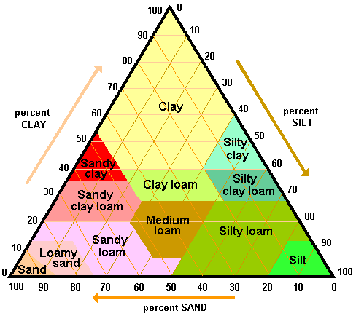
-Draw the separated layers and label each (estimate the percentages)
-Identify the type of soil in your sample by using the Soil Texture Triangle:

-Why do clay soils have such low permeability, despite being very porous?
-What three soil characteristics dictate a soil's water-holding capacity, aeration-Oxygen Content, and tilth?

- Is this a good soil for growing crops or not? Justify your answer.

-What type of soil would you have if there was 50 % Sand, 20% Silt, and 30% Clay?

-What would be the best soil type of crops? Justify your answer.

Fill in the Chart:exture
Type of Soil | Nutrient Holding | Leaching | Oxygen Content | Workability
SAND
SILT
CLAY
nt Infiltration Water-Holding Aeration Tilth
STATION #2: SOIL NUTRIENT TESTING
Plants need food (nutrients) for healthy growth. Nitrogen, Phosphorus and Potassium (N, P and K) play a vital role in plant growth just as vitamins, minerals, carbohydrates and protein do in our health.
NITROGEN (N)
Nitrogen is synonymous with plant nutrition. It is directly responsible for producing leaf growth and green leaves. A deficiency causes yellow leaves and stunted growth. Too much nitrogen causes overabundant foliage with delayed flowering; the plant becomes subject to disease and its fruit is of poor quality.

Phosphorus (P)
Growing plants need phosphorus. It is the major constituent of plant genetics and seed development. A deficiency causes stunted growth and seed sterility. Phosphorus aids plant maturity, increases the seed yield, increases fruit development, increases vitamin content aids the plant’s resistance to disease and winterkill.

Potassium (K)
Potassium strengthens the plant. It helps form carbohydrates and promotes protein synthesis. It will improve the color and flavor of fruit. It further aids early growth, stem strength and cold hardiness. Plants deficient in potassium are usually stunted and have poorly developed root systems. Leaves are spotted, curled and appear dried out at the edges. Yields for potassium deficiency are low.

pH
Plants also need the correct pH (acidity/alkalinity) level which controls how well plants utilize the nutrients available in your soil. All plants have a pH preference, so it is important to know the pH level of your soil. You can then choose plants with the same pH preferences, avoid those that will not do well in your soil or know how to go about supplying their special growing needs. By testing your soil, you determine its exact condition so that you can fertilize and/or adjust pH more accurately, effectively, and economically. [pH is the numeric value that indicates the relative acidity or alkalinity of a substance on a scale of 0 to 14, with the neutral point at 7. Acid solutions have pH values lower than 7; basic or alkaline solutions have pH values greater than 7.]

- Use the designated capsule with the matching container to determine the following of your sample:

Nutrient | Level
Nitrogen
Phosphorus
Potassium
pH

-Which of the above are limiting nutrients for plants, usually found in fertilizers:

-Explain the cause and effects of Eutrophication:

Based on the following Scenarios, what would you have to add to make the vegetation better:
- A tall sunflower begins to fall over from a weak stem:___________________
- A peach tree grows very large with an abundance of leaves, but not much fruit:____________________
- A hydrangea shrub has stunted growth without any foliage and minimal flower yield:_________________
-Write a conclusion about the nutrient capacity of your random sample (4-5) sentences:

