AP Chemistry Chromatography Lab NAME:

Introduction and Background:
There are two phases in paper chromatography, a stationary phase (the cellulose paper) and a mobile phase (the solvent). Cellulose will attract solvent molecules to the exposed hydroxyl (OH) groups along the paper polymer. This interaction makes a thin layer of solvent on the paper that competes for the attraction of the solute molecules attempting to be separated. The molecules can have a greater affinity for the paper or for the solvent. If the molecule is attracted to the solvent it will travel with the solvent up the paper. However, if the solute has a low affinity for the solvent, it will come out of solution and be deposited into the cellulose stationary phase. The relative attraction that each component of the solution has for the mobile phase (solvent) will allow you to separate each of the solutes in a mixture.

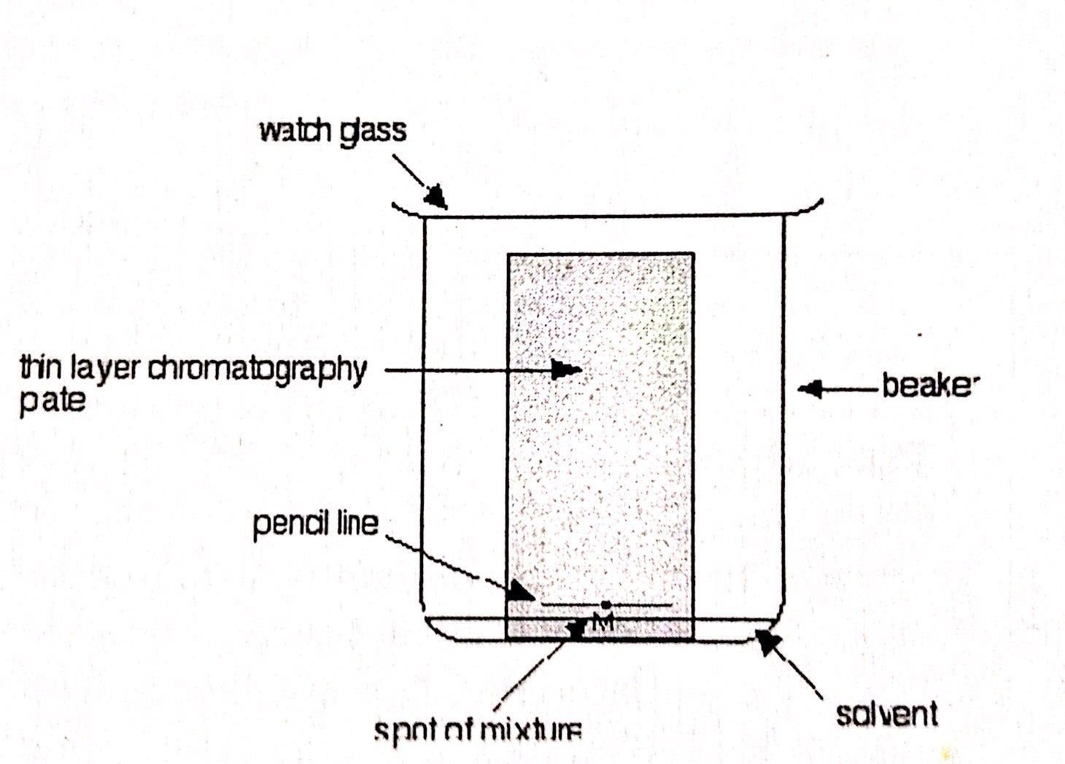
When doing chromatography, a small amount of solvent is placed in a sealed container. The mixture being separated is put on a piece of paper, the starting point is marked, and the paper is put into the solvent. The container must be sealed so the solvent saturates the paper and does not evaporate first. The level of separation is measured by a ratio that compares the distance that the molecule travels to the distance the solvent travels. This ratio is called the retention factor, or R_{f} value. To get the R_{f} value, the experimenter must first identify the distance that the solvent traveled on the paper and measure the distance. Secondly, the experimenter must identify the distance that the solute molecule traveled and measure that distance. The R_{f} value is a simplified ratio with the distance of the molecule divided by the distance of the solvent. The greater the distance the molecule travels, the greater its affinity for the solvent and the greater the R, value. It is best to run the test more than once to reach the best separation values possible.
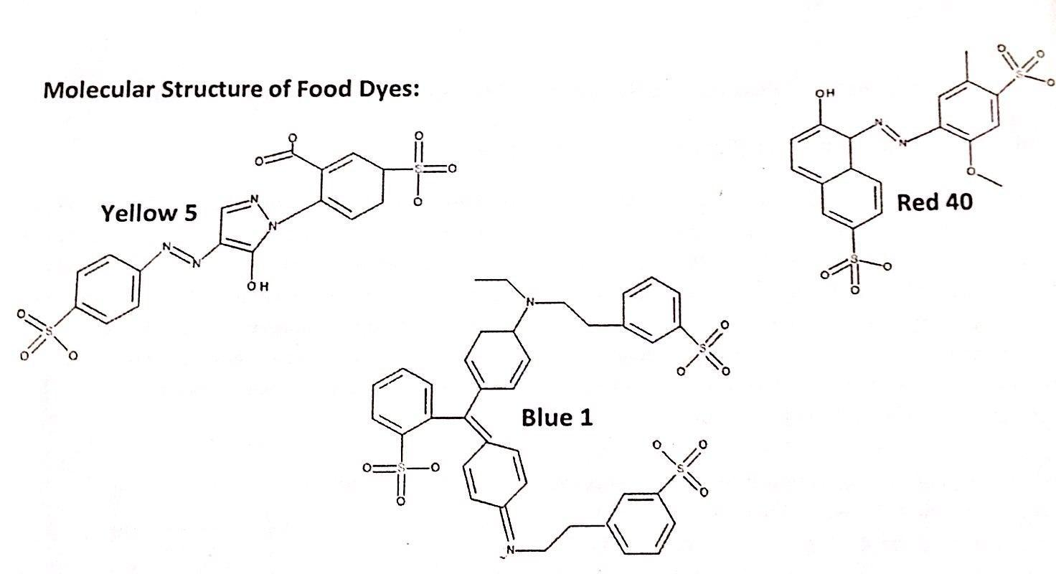
Procedure: watch the video, and then, using the information that follows, collect any necessary data and use it to answer the analysis questions that follow.
LAB VIDEO
Dye Molecule Structures (more detailed)

Molecular Structure of Solvents Used
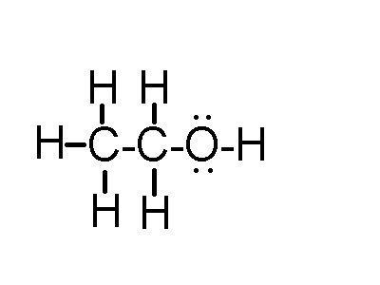 | 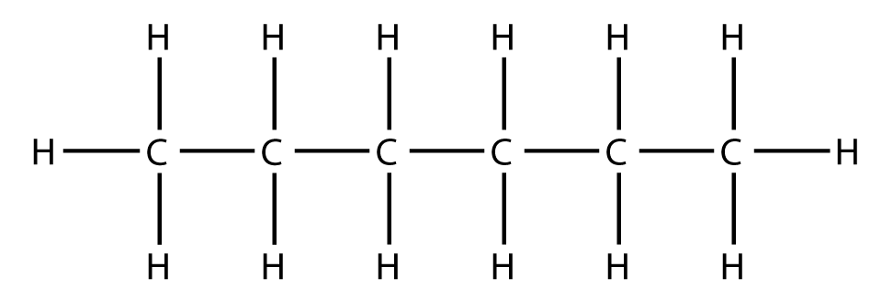 | 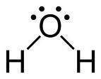 | 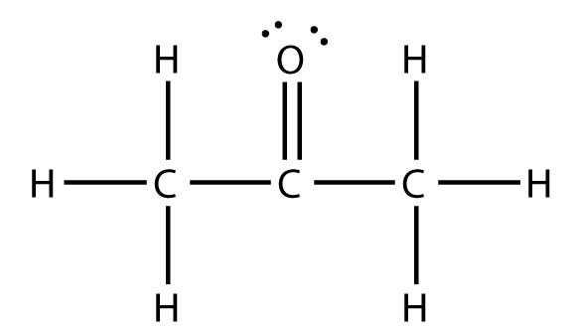 | 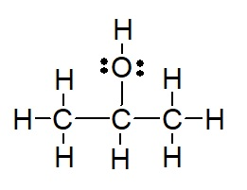
ethanol | hexane | water | acetone | 2-propanol

Data and Analysis:
- Measure the distance traveled by each dye where it applies.
- Measure the distance traveled by the solvent front (gray line to orange line)
- Calculate the Rf values where possible.
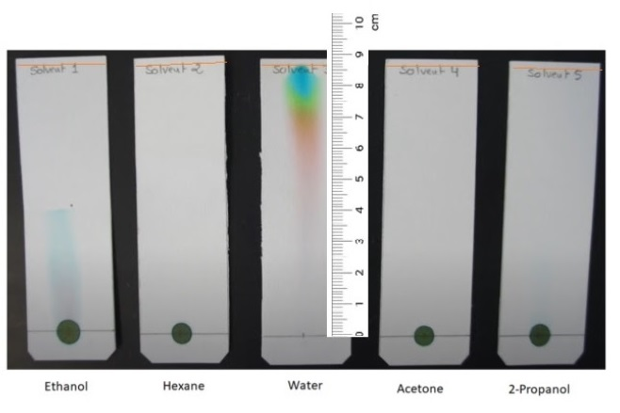
solvent | Dye distance (cm) |  |  | Solvent distance (cm) | Rf value
 | R | Y | B |  | R | Y | B
Ethanol
Hexane
Water
Acetone
2-Propanol

Calculations:
- Show the equation/sample calculations of how you found the Rf values.
Analysis Questions:
- When water was the solvent used, which food dye molecule spent the most time in the mobile phase? Why?
- Describe/list the intermolecular forces present between the molecules of each solvent, comparing and ranking them from the weakest to the strongest. Be specific in your explanations of why each is stronger than the next.
- Explain how intermolecular forces determine why certain solvents are better at separating the dyes. Consider the interactions/imfs between the dye molecules and the mobile phase (solvent) vs. the stationary phase (paper).
- In a different paper chromatography experiment, a sample of a pigment is separated into two components, X and Y, as shown in the figure below. The surface of the paper is moderately polar. Which of the pigments, X or Y, is more polar? Explain.

