Brionna Francis
APES
2/27/13
Leprosy

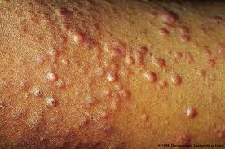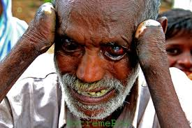
Leprosy is a non-communicable disease that affects the nerves and the upper respiratory tract. Leprosy is a chronic disease that is caused by bacteria. Leprosy is caused by a slow-growing type of bacteria called Mycobacteriumleprae. This disease is prevalent in places such as India, China, Romania, Egypt, Nepal, Somalia, Liberia, Vietnam, and Japan. Though this diseasr has been around since ancient times, it is uncertain how this disease is spread because more than 50% of people who get it have not been in contact with someone whom is infected which only makes this disease that much more confusing. Not only that but Leprosy is not highly contagious by any means. This is a misconception that originated long ago. Things that help leprosy to be contracted are environmental conditions, the degree of susceptibility of the person meaning a person’s defense system within their body, and if exposed the extent of exposure one has had. In fact many people can come in contact with an infected person and never become infected themselves.
Leprosy primarily affects the skin and the nerves outside the brain and spinal cord, called the peripheral nerves. It may also go for the eyes and the thin tissue lining the inside of the nose. Other symptoms include bumps that do not go away after several weeks or months. Usually the skin sores are a pale-color. If nerves are damaged other symptoms are loss of feeling in the arms and legs and muscle weakness. It can take up to 5 years or longer to get symptoms after contact has been made with the infected person.
Fortunately the cost of treatment for Leprosy is completely free for everyone. There is no real prevention for leprosy which too many is nerve racking but 1 person get Leprosy out of every 10,000 which though it’s not the smallest chance it’s easily treated with multiple antibacterial medicines. All in all Leprosy is a disease that is widely spread but easy to treat and completely curable. Those who do contract Leprosy have a 100% chance of recovering and leprosy doesn’t cause limbs to fall off, it compromised the defense system which allows other bacteria and infections to enter and cause issues leading to amputation.

