**Ebola**

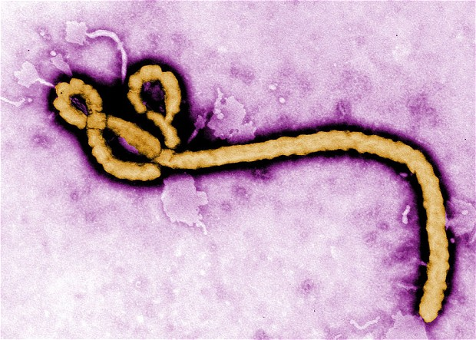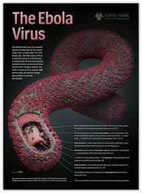

Ebola is a communicable disease that affects the levels of white blood cells and platelets, causing one to bleed to death at a rapid spead. While the exact cause of Ebola is unknown scientist have pretty much said it is not air born but caught by the exchange of bodily fluids. The contact between animals and humans are the cause for this virus which is why places like Africa are the places where this virus is being found because they spend a lot of their time in the jungle trying to find food. When a person as EBOV some symptoms are very common to the flu or food poisoning they are Fever, Sore throat, Weakness, Severe headache, Diarrhea, Vomiting, Dehydration, Dry hacking cough, and stomach pain. But than there comes joint pain and bleeding. The Ebola virus kills about 90% of its hosts so treatments are usually useless. There are a few strategies to keep the ebola virus from spreading such as isolating them from everyone but as far as treatments it is fluids, oxygen to help with breathing, medication to reduce fever and blood clots and antibiotics to prevent secondary infections from bacteria. There have been many attempts to find the cure for EBOV but as of right now time is the only cure.

Since the discovery of Ebola virus in 1976, there have been 13 human outbreaks in

Africa. In total, Ebola virus infected about 1850 people and caused nearly 1300 deaths. The different Ebola virus subtypes showed a certain geographic pattern, E. Ivory Coast affecting West Africa, E. Sudan east Africa, and E. Zairecentral Africa. Although both mechanisms of spread probably play a role, evidence are now growing that apes are indeed passing the virus to each other within social group, between social groups, and even between species. Threat on ape populations living in contiguous forest is thus very strong as ape-to-ape transmission act as an amplifier of Ebola outbreaks.

<http://ebola.emedtv.com/ebola/ebola-treatment.html>

<http://www.cdc.gov/ncidod/dvrd/spb/mnpages/dispages/ebola/qa.htm>

<http://www.news-medical.net/health/What-is-Ebola.aspx>