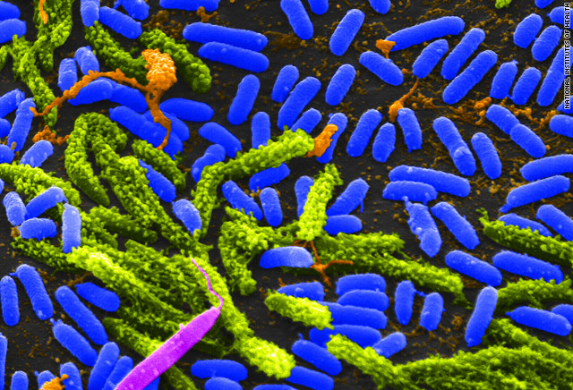
Yasmine.Soumahoro
A.P Environmental Science
6th Period

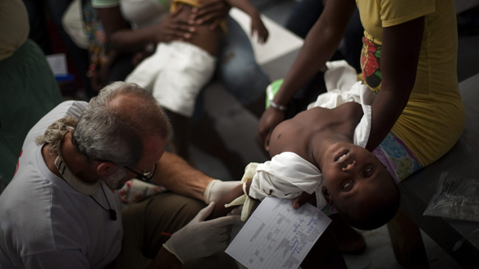
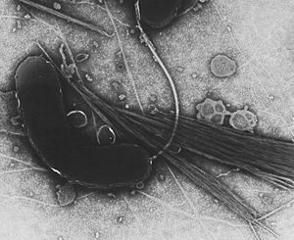
Human Disease Project: Cholera
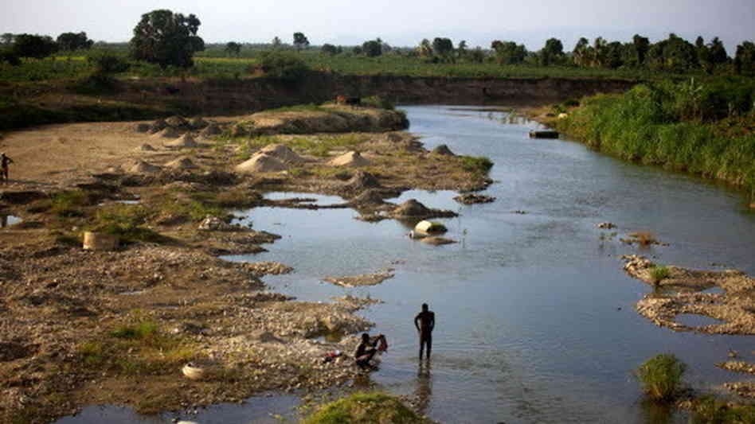

Introductory statement- Cholera is an infectious disease caused by bacteria in the small intestine. It is a disease which is very commicable because it is easily spreadable. It affects the digestive system along with the intestinal system.
Causes/Catch- Contaminated water is the main source of cholera. But contributing factors like raw shell fish, uncooked fruits and vegetables can cause it too. People living in developing nations are at higher risk of getting cholera because they have a poor water sanitation system. Feces waste and all kinds of other materials in those waters contribute to the causation of cholera. A person can catch this disease by eating raw food, drinking un sanitized or unclean water, or by getting infected by someone else through contact.
Symptoms- The symptoms of choleraare diarrhea which makes the body excrete a lot of water, dehydration, nausea, and vomiting. People began noticing sighs of cholera by having irritability, lethargy, sunken eyes, dry mouth and extreme thirst.
Treatment- Cholera requires immediate treatment because it can cause death within hours. The treatment methods are rehydration which is done to restore electrolytes and lost fluids. Then the use of antibiotics and immunizations which kills bacteria. And Zinc supplements which decrease the duration of cholera.
Cost- I couldn’t get the cost of cholera treatments for the U.S but this did get some data from Ecuador in 1994. Also it is a fact that men’s treatment of cholera is a little more expensive than women treatments.
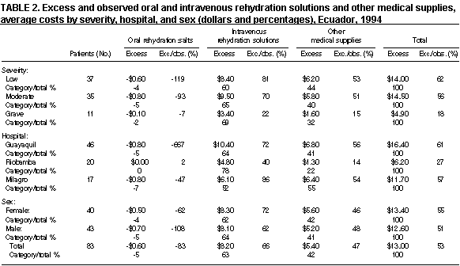

Prevention- To prevent getting cholera you should 1. drink and use safe water, which means if you are unsure about the water you are using then it should be boiled and treated with chlorine. 2. Make sure the places used for cooking are cleaned and sanitized properly. 3. Wash your hands often with soap and water, and 4. Cook your food well and avoid eating raw food, because it puts you at greater risk.
- Stats/Facts- Since 2005 cholera incidents have increased globally with outbreaks affecting several continents. It continues to cause serious health problems in developing nations who have no access to clean or adequate water. In 2011 32% of cases were reported in Africa, where as between 2011 and 2009, 93% to 98% of total causes worldwide were reported from that continent alone. There are an estimated 3-5 million cases of cholera and 100,000-120,000 deaths due to cholera each year and up to 80% of the cases can be treated with rehydration salts.
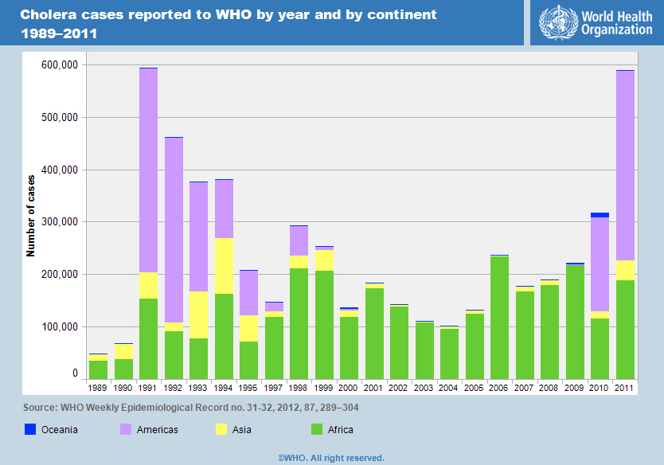

Works Cited:

www.cdc.gov

www.mayoclinic.com

www.diahhrea.emedtv.com

www.publichealth.com

