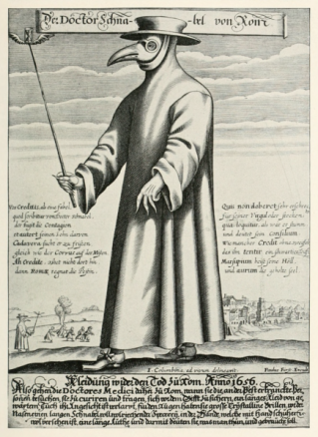
Bubonic Plague

The Bubonic Plague also known as the Black Death is a communicable disease that affects the carrier’s lymph nodes and immune system. The disease arrived in the early 1300s, when ships from China docked in Europe. The traders that arrived on these vessels brought with them a dangerous plague that swept through Europe from 1347 to 1354 leaving a death count beyond the toll of grief in its wake. This pandemic, that later became known as The Black Death killed nearly sixty percent of Europe’s population. The deaths that resulted from the indiscriminate killing of the disease were the foundations on which fear was forged and almost completely initiated the fall of a nation.
The plague or the Black Death was usually transmitted from rats and fleas to humans, and could even be transmissible through intercourse with an infected person. The bacteria from the flea would then enter the blood stream and reproduce in the lymph nodes of its victims. The Bubonic Plague is caused by an infection of the Yersinia pestis bacterium which survives in the stomachs of fleas, which are carried on rats. Once a person has been bitten by a flea, it may take 2 to 6 days for the symptoms to occur and reveal the disease’s actual prevalence. If not treated, death is very eminent, and death can occur within one week after being infected. Unfortunately the plague was not confined within one population, general area, or even country. It is speculated that it may have been spread along the Silk Road with Mongol armies and traders, but traveled across numerous countries including Constantinople, Rome, Barcelona, and Paris within only three years.
The bubonic plague was not only responsible for millions of deaths, but is infamous for the agonizing pain that it inflicted on its victims. The plague was characterized by high fevers, chills, vomiting, muscle cramps, seizures, and the most prominent, swollen and painful lymph nodes known as buboes, which are often found under armpits, in the groin and on necks. The symptoms of the plague are so severe that the infected person could literally begin decomposing and decaying even while he or she was still alive. In other forms of The Plague such as Pneumonic and Septicemic, the symptoms can be much more severe. Louis Heyligen, a musician who died from the disease in 1348, noted that he developed a bloody cough upon contracting Pneumonic Plague also known as the Lung Plague. Other physical symptoms include diarrhea, nausea, abdominal pain, and dehydration. Although the bubonic plague is not always deadly, the sudden appearance of dark buboes meant that the victim would certainly die from infection.
Fortunately, the plague is a curable disease, but people potentially infected should seek treatment within twenty-four hours of the first symptoms. Antibiotics such as Streptomycin can be utilized to kill off the infection. Antibiotics accompanied by other medication to treat the swelling and pain associated with the disease are enough to completely eradicate it from a person’s body. The plague can be easily prevented by reducing rodent populations through the cultivation of more sanitary environments. Rodent populations and infection rates should be closely monitored to prevent the plague from becoming a serious epidemic. Other treatments of the plague include respiratory support, intravenous fluids and oxygen. Although all methods of treatment and prevention have been proven to be successful, a possible carrier should be treated within twelve hours of infection to ensure that death does not become definite. Providentially, the plague can be treated at reasonable prices, with cost ranging from $80-100 per day. The plague can be eliminated within seven to ten days of therapy, with the most common antibiotic treatments being Streptomycin, Doxycycline, Tetracycline, and Gentamicin. Combined with the cost of hospitalization which is usually around $500-800 per day, the plague is a disease that can be treated, and is fairly reasonable.
The contagious catastrophe known as the plague or Black Death fostered complete fear and panic that sent a frightened ripple down Europe’s spine. The subsequent outbreaks of the plague imparted an indelible fear and cautiousness that has resonated not only with the people of Europe, but instilled an almost neurotic dread of germs with American culture as well. The surplus of products, infamous for harming the environment can be attributed to epidemics such as the plague, due in part of an irrational fear encouraged through media forms which portray germs as the mortal enemy to health. The plague was such a pandemic that it even halted the construction of a great Cathedral in Sienna, which back then was an essential place for healing and repentance. Despite many doctors adorning bird like masks with herbs stuffed in the beaks-usually lavender, the plague was an almost inescapable disease due to the ignorance of the people during that time. The Plague will remain as one of the greatest pandemics in human history, and has left its infamous mark that will continue to reverberate through time.

Works Cited
http://www.sfcdcp.com/plague.html
http://facts.randomhistory.com/2009/06/09_black-death.html
http://health.nytimes.com/health/guides/disease/plague/overview.html

